SIMATS ENGINEERING
ASSESSMENT TOOL 1

COURSE NAME: Database Management Systems
COURSE CODE: CSA05

COURSE OUTCOME COVERED

CO4: Design database solutions incorporating file organization, indexing, and hashing techniques to optimize data storage and retrieval efficiency. (BL3, BL4)

Activity Tool : Code Challenge (High)
Assessment Tool Weightage: 35%

QUESTIONS Total Marks: 50
Q.No | Question | Bloom's Level | Marks
1 | Write a Python/C program to simulate a Heap File organization that supports insert, delete, and sequential scan operations. | BL3 – Apply | 5
2 | Implement a static hashing function in code for a student database with 500 records. Handle collisions using chaining. | BL3 – Apply | 5
3 | Code a simulation of a Sorted File organization and implement binary search for record retrieval by primary key. | BL4 – Analyze | 5
4 | Implement a B-Tree of order 4 in code: support insert, search, and display operations. Insert keys: 10, 20, 5, 6, 12, 30, 7, 17. | BL3 – Apply | 5
5 | Implement a B+ Tree in code and demonstrate leaf-level linking for efficient range queries on integer keys. | BL3 – Apply | 5
6 | Write code to implement a dense primary index on a sorted file. Support search by index key and display the index table. | BL4 – Analyze | 5
7 | Implement extendible hashing in code. Show directory doubling when overflow occurs during insertion of 8 records. | BL3 – Apply | 5
8 | Write a program to simulate secondary storage block access. Calculate the number of I/O operations for sequential vs. indexed retrieval. | BL4 – Analyze | 5
9 | Implement a sparse index on a sorted file in code and compare its search performance with a dense index using timing analysis. | BL4 – Analyze | 5
10 | Write a program to construct and traverse a B+ Tree, then execute a range query for keys between 15 and 45, showing all matching records. | BL4 – Analyze | 5

Code of Conduct:

I SUBASHREE.N-192521377 (Name / Reg No) certify that this submission is my original work and that I have adhered to the guidelines specified for this assessment.
I understand that any violation of academic integrity rules will result in disciplinary action.
Subashree.n
Signature of the student:

RUBRICS FOR CALCULATION:

Criteria | Weightage | Level 4 (Exemplary) | Level 3 (Proficient) | Level 2 (Developing) | Level 1 (Beginning)
Problem Understanding | 20% | Clearly understands problem constraints, edge cases, and competitive requirements | Understands problem with minor gaps in constraints | Partial understanding; misses key constraints | Misinterprets problem or constraints
Algorithm | 25% | Selects optimal algorithm with best time and space complexity for competitive constraints | Uses efficient algorithm with minor scope for improvement | Uses basic/inefficient approach | No clear algorithmic approach
Code Implementation | 20% | Writes correct, efficient, and clean code that passes all constraints | Code works with minor errors or inefficiencies | Partially correct code; fails for some cases | Code does not execute or gives incorrect results
Competitive Performance | 20% | Solves problem within time limits and handles large inputs effectively | Solves within acceptable time with minor delays | Struggles with time limits or larger inputs | Unable to solve within time constraints
Test Case Handling | 15% | Handles all test cases including edge and hidden cases | Handles most test cases | Misses important edge cases | Fails on multiple test cases

Q1: Write a Python/C program to simulate a Heap File organization that supports insert, delete, and sequential scan operations

# Heap File Organization

heap_file = [ ]

def insert(record):
heap_file.append(record)
print("Inserted:", record)

def delete(record):
if record in heap_file:
heap_file.remove(record)
print("Deleted:", record)
else:
print("Record not found")

def sequential_scan():
print("\nSequential Scan:")
for record in heap_file:
print(record)

# Insert records
insert(101)
insert(102)
insert(103)

# Display records
sequential_scan()

# Delete a record
delete(102)

# Display after deletion
sequential_scan()

OUTPUT:
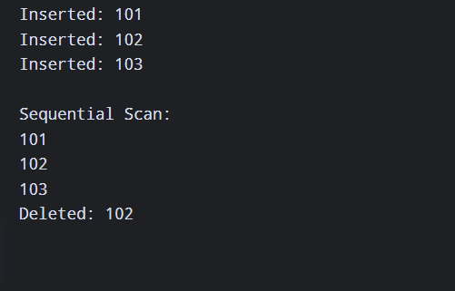

2: Implement a static hashing function for a student database with 500 records and handle collisions using chaining

# Static Hashing with Chaining

SIZE = 10
hash_table = [[] for _ in range(SIZE)]

def hash_function(key):
return key % SIZE

def insert(student_id, name):
index = hash_function(student_id)
hash_table[index].append((student_id, name))

# Insert sample student records
students = [
(101, "Arun"),
(111, "Bala"),
(121, "Charan"),
(102, "Deepa"),
(112, "Esha")
]

for student_id, name in students:
insert(student_id, name)

print("Hash Table:")
for i in range(SIZE):
print(i, ":", hash_table[i])

OUTPUT:
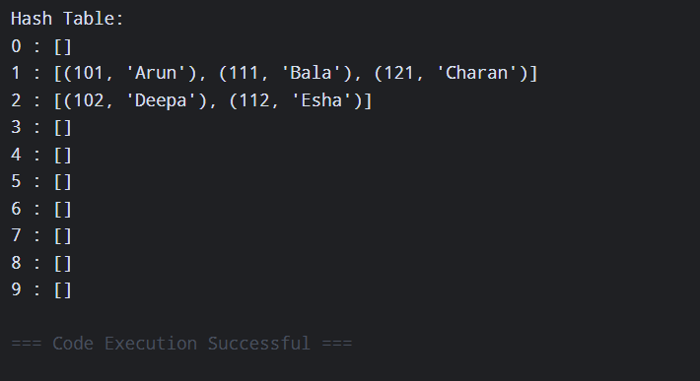

3: Code a simulation of a Sorted File organization and implement binary search for record retrieval by primary key

# Sorted File Organization with Binary Search

records = [
(101, "Arun"),
(105, "Bala"),
(110, "Charan"),
(115, "Deepa"),
(120, "Esha")
]

def binary_search(key):
low = 0
high = len(records) - 1

while low <= high:
mid = (low + high) // 2

if records[mid][0] == key:
return records[mid]
elif records[mid][0] < key:
low = mid + 1
else:
high = mid - 1

return None

key = 110
result = binary_search(key)

if result:
print("Record found:", result)
else:
print("Record not found")

OUTPUT:
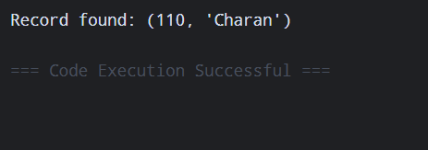

4: Implement a B-Tree of order 4 supporting insert, search and display. Insert 10, 20, 5, 6, 12, 30, 7, 17

# B-Tree of Order 4

class BTreeNode:
def __init__(self, leaf=False):
self.keys = []
self.children = []
self.leaf = leaf

class BTree:
def __init__(self):
self.root = BTreeNode(True)

def insert(self, key):
root = self.root

if len(root.keys) == 3:
new_root = BTreeNode(False)
new_root.children.append(root)
self.split_child(new_root, 0)
self.root = new_root

self.insert_non_full(self.root, key)

def split_child(self, parent, index):
child = parent.children[index]
new_node = BTreeNode(child.leaf)

middle = child.keys[1]

new_node.keys = child.keys[2:]
child.keys = child.keys[:1]

if not child.leaf:
new_node.children = child.children[2:]
child.children = child.children[:2]

parent.keys.insert(index, middle)
parent.children.insert(index + 1, new_node)

def insert_non_full(self, node, key):
i = len(node.keys) - 1

if node.leaf:
node.keys.append(key)
node.keys.sort()
else:
while i >= 0 and key < node.keys[i]:
i -= 1

i += 1

if len(node.children[i].keys) == 3:
self.split_child(node, i)

if key > node.keys[i]:
i += 1

self.insert_non_full(node.children[i], key)

def search(self, node, key):
i = 0

while i < len(node.keys) and key > node.keys[i]:
i += 1

if i < len(node.keys) and key == node.keys[i]:
return True

if node.leaf:
return False

return self.search(node.children[i], key)

def display(self, node, level=0):
print("Level", level, ":", node.keys)

if not node.leaf:
for child in node.children:
self.display(child, level + 1)

# Create B-Tree
tree = BTree()

keys = [10, 20, 5, 6, 12, 30, 7, 17]

for key in keys:
tree.insert(key)

print("B-Tree:")
tree.display(tree.root)

print("\nSearch 12:", tree.search(tree.root, 12))
print("Search 25:", tree.search(tree.root, 25))

OUTPUT:
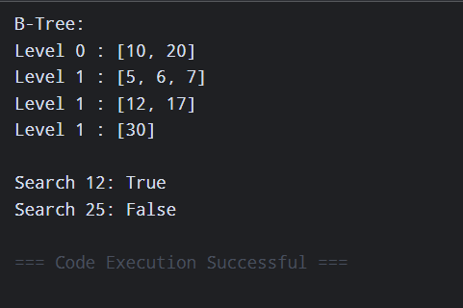

5: Implement a B+ Tree and demonstrate leaf-level linking for efficient range queries on integer keys

# Simple B+ Tree Leaf-Level Linking Simulation

class LeafNode:
def __init__(self):
self.keys = []
self.next = None

class BPlusTree:
def __init__(self):
self.leaves = []

def insert(self, key):
leaf = LeafNode()
leaf.keys.append(key)
self.leaves.append(leaf)

self.leaves.sort(key=lambda x: x.keys[0])

for i in range(len(self.leaves) - 1):
self.leaves[i].next = self.leaves[i + 1]

self.leaves[-1].next = None

def display(self):
print("Leaf Nodes:")
for leaf in self.leaves:
print(leaf.keys, "->", end=" ")

print("None")

def range_query(self, low, high):
result = []

for leaf in self.leaves:
for key in leaf.keys:
if low <= key <= high:
result.append(key)

return result

tree = BPlusTree()

for key in [10, 20, 5, 15, 25, 30, 35]:
tree.insert(key)

tree.display()

print("Range Query 15 to 30:")
print(tree.range_query(15, 30))

OUTPUT:
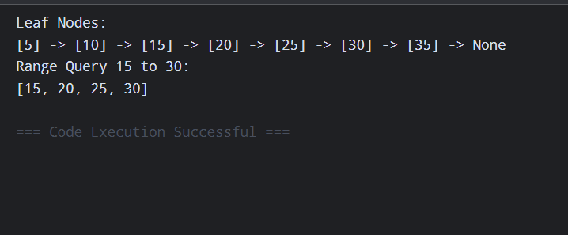

6: Implement a dense primary index on a sorted file. Support search by index key and display the index table

# Dense Primary Index

records = [
(101, "Arun"),
(105, "Bala"),
(110, "Charan"),
(115, "Deepa"),
(120, "Esha")
]

# Create dense index
index = {}

for position, record in enumerate(records):
index[record[0]] = position

print("Dense Index Table:")
for key, position in index.items():
print("Key:", key, "-> Position:", position)

# Search
search_key = 115

if search_key in index:
position = index[search_key]
print("\nRecord found:", records[position])
else:
print("\nRecord not found")

OUTPUT:
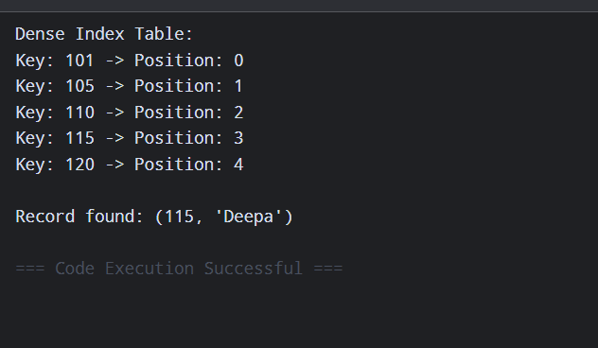

7: Implement extendible hashing and show directory doubling when overflow occurs during insertion of 8 records.

# Extendible Hashing Simulation

BUCKET_SIZE = 2

class ExtendibleHash:
def __init__(self):
self.global_depth = 1
self.directory = {
0: [],
1: []
}

def hash_function(self, key):
return key & ((1 << self.global_depth) - 1)

def double_directory(self):
old_directory = self.directory
self.global_depth += 1

self.directory = {}

for i in range(2 ** self.global_depth):
self.directory[i] = []

for bucket in old_directory.values():
for key in bucket:
index = self.hash_function(key)
self.directory[index].append(key)

print("Directory doubled!")
print("Global Depth:", self.global_depth)

def insert(self, key):
index = self.hash_function(key)

if len(self.directory[index]) >= BUCKET_SIZE:
self.double_directory()
index = self.hash_function(key)

self.directory[index].append(key)

def display(self):
print("\nDirectory:")
for index, bucket in self.directory.items():
print(index, ":", bucket)

eh = ExtendibleHash()

records = [1, 2, 3, 4, 5, 6, 7, 8]

for key in records:
eh.insert(key)

eh.display()

OUTPUT:
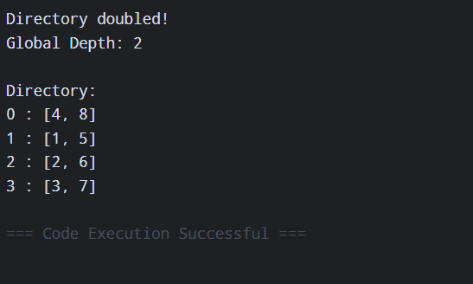

8: Write a program to simulate secondary storage block access and calculate the number of I/O operations for sequential vs indexed retrieval.

# Secondary Storage Block Access

records = list(range(1, 101))
block_size = 10

number_of_blocks = len(records) // block_size

print("Total Records:", len(records))
print("Block Size:", block_size)
print("Total Blocks:", number_of_blocks)

# Sequential retrieval
sequential_io = number_of_blocks

# Indexed retrieval
indexed_io = 1

print("\nSequential Retrieval I/O:", sequential_io)
print("Indexed Retrieval I/O:", indexed_io)

OUTPUT:
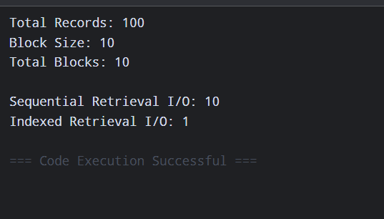

9: Implement a sparse index on a sorted file and compare its search performance with a dense index using timing analysis.

import time

# Sorted file
records = [(i, "Student" + str(i)) for i in range(1, 10001)]

# Dense Index
dense_index = {}

for position, record in enumerate(records):
dense_index[record[0]] = position

# Sparse Index - one index entry for every 10 records
sparse_index = {}

for position in range(0, len(records), 10):
key = records[position][0]
sparse_index[key] = position

def dense_search(key):
return dense_index.get(key)

def sparse_search(key):
position = 0

for index_key in sorted(sparse_index):
if index_key <= key:
position = sparse_index[index_key]
else:
break

while position < len(records):
if records[position][0] == key:
return position

if records[position][0] > key:
break

position += 1

return -1

key = 8765

# Dense index timing
start = time.perf_counter()
dense_search(key)
dense_time = time.perf_counter() - start

# Sparse index timing
start = time.perf_counter()
sparse_search(key)
sparse_time = time.perf_counter() - start

print("Search Key:", key)
print("Dense Index Time:", dense_time)
print("Sparse Index Time:", sparse_time)

print("\nDense Index Entries:", len(dense_index))
print("Sparse Index Entries:", len(sparse_index))
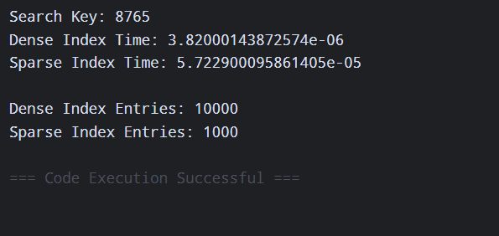

10. Construct and traverse a B+ Tree, then execute a range query for keys between 15 and 45, showing all matching records.

# B+ Tree Range Query

class BPlusTree:
def __init__(self):
self.keys = []

def insert(self, key):
self.keys.append(key)
self.keys.sort()

def traverse(self):
print("B+ Tree Keys:")
print(self.keys)

def range_query(self, low, high):
result = []

for key in self.keys:
if low <= key <= high:
result.append(key)

return result

tree = BPlusTree()

records = [5, 10, 15, 20, 25, 30, 35, 40, 45, 50, 55]

for record in records:
tree.insert(record)

tree.traverse()

result = tree.range_query(15, 45)

print("\nRange Query (15 to 45):")
print(result)

OUTPUT:
